Project Report

Convolutional Neural Network (CNN) for Image Classification using CIFAR-10 Dataset

Source code: Asgn-2.ipynb
Dataset link:https://archive.ics.uci.edu/dataset/691/cifar+10

Title
Image Classification using Convolutional Neural Network (CNN) on the CIFAR-10 Dataset

Problem Statement
Image classification is one of the most important applications of Deep Learning and Computer Vision. The objective of this project is to develop a Convolutional Neural Network (CNN) capable of automatically classifying color images into one of the ten predefined categories available in the CIFAR-10 dataset. The model is trained using supervised learning techniques and evaluated based on its classification accuracy and loss. The project demonstrates the effectiveness of CNNs in extracting image features and performing multi-class image classification.

Dataset Description
The CIFAR-10 dataset is a benchmark dataset widely used for image classification tasks. It contains 60,000 color images of size 32 × 32 pixels divided into 10 different classes.
The ten classes in the dataset are:
- Airplane
- Automobile
- Bird
- Cat
- Deer
- Dog
- Frog
- Horse
- Ship
- Truck
The dataset is divided into:
- Training Images: 50,000
- Testing Images: 10,000
- Image Size: 32 × 32 × 3 (RGB Color Images)
- Number of Classes: 10
The dataset is directly available through the TensorFlow Keras library.

Data Preprocessing Steps
The following preprocessing steps were performed before training the CNN model:
- Loaded the CIFAR-10 dataset using TensorFlow Keras.
- Displayed sample images to understand the dataset.
- Normalized pixel values by dividing each pixel by 255 so that all values lie between 0 and 1.
- Converted the class labels into one-hot encoded vectors using the to_categorical() function.
- Prepared the processed data for training and testing.
These preprocessing steps improve model convergence and help achieve better classification performance.

Exploratory Data Analysis (EDA)
Before training the model, several sample images from the dataset were visualized to understand the characteristics of different image classes. The dataset contains balanced samples from ten object categories, with each image represented as a 32 × 32 RGB image.
The visualization confirmed that the dataset contains diverse objects with varying backgrounds, colors, and viewing angles, making the classification task challenging. The sample images also verified that the dataset had been loaded correctly before preprocessing and model training.

Model Used
A Convolutional Neural Network (CNN) was developed using the TensorFlow Keras Sequential API for image classification. The architecture consists of the following layers:
- Conv2D Layer: 32 filters of size 3 × 3 with ReLU activation.
- MaxPooling2D Layer: Pool size of 2 × 2 for dimensionality reduction.
- Conv2D Layer: 64 filters of size 3 × 3 with ReLU activation.
- MaxPooling2D Layer: Pool size of 2 × 2.
- Flatten Layer: Converts the extracted feature maps into a one-dimensional vector.
- Dense Layer: 128 neurons with ReLU activation.
- Output Layer: 10 neurons with Softmax activation for multi-class classification.
The model was compiled using the Adam optimizer and categorical cross-entropy loss function. Accuracy was used as the evaluation metric during training and testing.
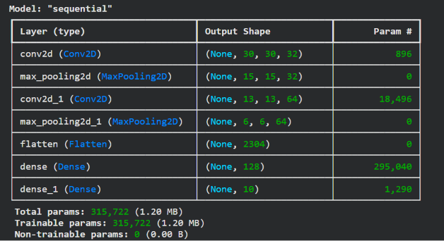

Training Process
The CNN model was trained using the preprocessed CIFAR-10 training dataset.
Training configuration:
- Optimizer: Adam
- Loss Function: Categorical Cross-Entropy
- Evaluation Metric: Accuracy
- Epochs: 10
- Batch Size: 64
- Validation Split: 20%
During training, both training accuracy and validation accuracy were monitored for each epoch. Similarly, training loss and validation loss were recorded to analyze the learning performance of the model.
The model gradually improved its performance over successive epochs and learned meaningful image features required for classification.
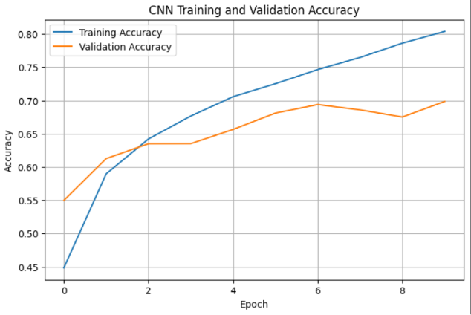

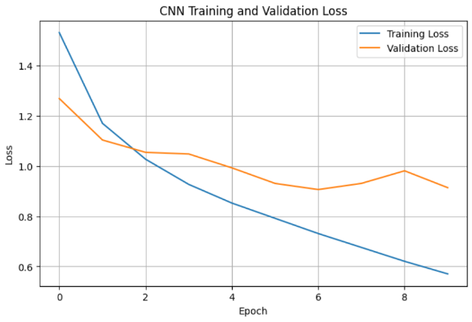

Evaluation Metrics and Results
After training, the model was evaluated using the testing dataset.

Performance Results
- Training Accuracy: 80.40%
- Validation Accuracy: 69.86%
- Test Accuracy: 69.46%
- Test Loss: 0.9346
The model achieved a test accuracy of 69.46%, indicating that it correctly classified approximately seven out of every ten unseen images.
The training and validation accuracy graphs show the learning progress of the model, while the loss curves illustrate the reduction in prediction error during training.
A confusion matrix was generated to visualize the classification performance across all ten image classes. Sample predictions were also displayed to compare the predicted labels with the actual labels.
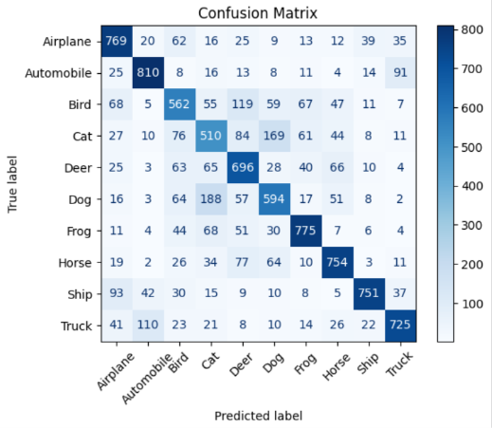

Conclusion
In this project, a Convolutional Neural Network (CNN) was successfully implemented to classify images from the CIFAR-10 dataset into ten different categories. The dataset was preprocessed by normalizing pixel values and converting class labels into one-hot encoded vectors before training.
The CNN learned useful image features through convolution and pooling operations and achieved a test accuracy of 69.46%. Although some misclassifications occurred due to the complexity of the dataset, the model demonstrated the effectiveness of CNNs in solving image classification problems.
Future improvements such as adding more convolutional layers, applying dropout, using batch normalization, performing data augmentation, and training for more epochs can further improve the classification accuracy.

References
- TensorFlow Keras Documentation: https://www.tensorflow.org/
- CIFAR-10 Dataset:
https://www.cs.toronto.edu/~kriz/cifar.html
- TensorFlow Keras Datasets:
https://www.tensorflow.org/api_docs/python/tf/keras/datasets/cifar10
- Chollet, F. Deep Learning with Python. Manning Publications.

